Thermal Soaring Forecasts
This document outlines the step-by-step process I use to prepare thermal soaring forecasts for the ABE area. It contains all of the links I use and whenever it is not obvious how to modify those links to work on any other METAR site I have provided direction.
PART 1 is in narrative form and contains details which assume litle knowledege. PART 2 is a greatly simplified cookbook approach which will be useful once Part 1 is mastered.
PART 1: MAKING THE FORECAST
The single most important tool used in preparing thermal soaring forecasts is the thermodynamic or SkewT diagram. It is certainly possible to produce a qualitatively plaausible forecast without reference to these diagrams, particualry with a good deal of experience to rely upon. On the other hand failure to make full use of them will alwys result in an inferior forecast.
Traditionally, it has been the morning ballon sounding, always reported in SkewT format (at least in the US) which has been used to produce thermal soaring forecasts. Within the past decade however, numerical models have become poerful enough
My home page on my browser is Unisys Weather and this is where I start with the current satellite image and surface map. This provides the best overall picture of the day, and has the added advantage that it can be looped. I next read the local NWS office discussion (click the map with the states outlined and labelled). Although frequently highly technical, and always sprinkled with arcane contractions, these discussions are an absolutely essential part of the data gathering process. They give the professional’s assessment of the validity of the various models, and an overall assessment of the synoptic and prognosticative picture. They provide the indispensable background against which I evaluate data. They alsso will generally comment when ther is significant divergence in the various models and will advise on which is handling the current situation best.
The Unisys site also has an excellent Satellite/Surface Composite image and I generally look at this as well as the IR Satellite Radar Composite.
I always use the NASA GHCC Interactive Global Geostationary Weather Satellite Image Viewer for high resolution visible images – these resolve individual cumulus clouds (at least the larger ones) and give the clearest possible picture of the evolution of clouds of all types through the looping capability. They are generally current to about 15 minutes. Early in the morning the visible satellite images are of course not visible, so I use the IR images. Apart from a slight tendency to make matters look rather worse than they are, these are an excellent substitute. The water vapor images are also very useful, particularly given the pivotal role which water vapor often plays in soaring weather.
The best possible estimates of surface temperatures and dewpoints are essential. I always look at the MOS (Model Output Statistics) for three operational models (NAM, NGM, GFS) then compare these to the reported values of T and DP. I also use the Acuweather site which allows me to drill down to hourly forecasts of T and DP and it is frequently the case that this is the best data for the day. I alwys check for any disparity between forecast and observed temperature and DP values – this can be an early warning of trouble to come. It is also frequently revealing to look at upwind observations.
With the groundwork in place, I next look at the RUC BLIPMAP and the ETA BLIPMAP (now officially “NAM” for North American Mesoscale). Considerable care needs to be exercised in using these. The RUC in particular frequently has its own very different ideas on surface DP values and this can undermine many aspects of the forecast. This is why I always refer to the MOS data. Regardless of errors in cloud parameter forecasts which arise from surface DP errors, the trends of the BLIPMAPS are of great value. At a glance it can be seen where conditions might be better or worse.
I find Dale Kremers “Bmapper” to be far more useful than the standard BLIPMAP display. Not only does it overlay the RUC 25 km grid on the task area and waypoints, it also gives access to 11AM and 5 PM data as well as 2 PM data, and it makes it very easy to generate a sounding at any grid point. To get the sounding from FSL all that is needed is to right click the grid point circle. This allows me to assess individual grid point soundings over the entire task area.
The final step in preparing the forecast is to estimate the strength and height of the lift for the day and of course to see if cumulus clouds will form and if so at what height. I start be making the best possible estimate of the depth of the convective boundary layer. This is something the BLIPMAP does well, but I always confirm those values by looking at several individual soundings. The top of the convective BL is the maximum height to which we can expect to climb. This is because by definition the convective BL is that part of the atmosphere convectively mixed to the DALR. On many days, particularly in the East, we are not going to get that high however, for the very good reason that cumulus clouds form. So, how do we know if they will form, and if so, at what height? One way is simply to click the bottom right end of the sounding on the FSL site and see where the black line appears: If it is to the right of the temperature lapse curve cu will form, if to the left, they will not. The problem with this approach is that the RUC gets the surface DP wrong rahter more often than do the various MOS forecasts. A simple alternative, and one which I have found to be far more reliable and accurate, is to take the difference in surface DP and T (both in Fahrenheit), divide that difference by 4.4, then multiply the quotient by 1,000 to get the height of the cumulus cloudbase (AGL!) in feet. If that number is less than the height of the top of the BL, cu will form, if greater, they will not. If close, it’s a tossup. It is also possible to enter a modified value of the surface DP on the FSL plot by right clicking after placing the cursor at the bottom of the superadiabatic layer (bottom right hand corner of the temperature profile). A dialog box then allows numerical entry of T and DP. The value of the surface temperature should be the default value output by the model. There seems to be an irresistable temptation to “tweak” the model value but it should be understood the model computes the values of the temperature in the convective boundary layer using the surface temperature as an input. Changes in the latter necessarily result in changes in the latter. It might be objected that adjusting the value of the surface dewpoint is also not sensible but for the limited purpose of determining cumulus cloudbase it is quite legitimate.
No soaring forecast is compete without winds. I generally rely on the RUC. I always include surface and 30,000 ft winds. The former are of obvious importance, the latter control to motion of cirrus and are usually representative of the overall motion of weather systems. For ridge sites I always include winds at ridge height. I generally give winds at every 2,000 ft in the BL.

PART 2: THERMODYNAMIC DIAGRAMS
The SkewT Diagram
The figure below may look pretty forbidding but to me it looks like a pretty good blue day with lift to about 6,000 feet.

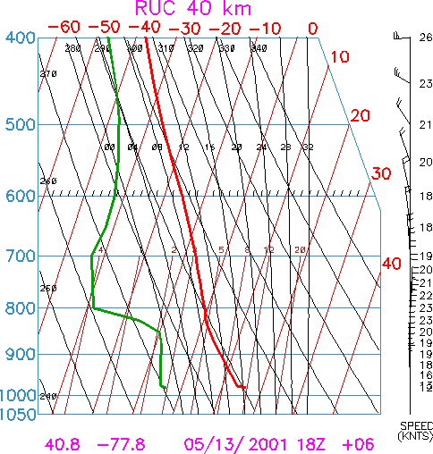
In the following discussion I will provide sufficient guidance on these diagrams to enable anyone else to take a quick look and draw some pretty valid conclusions about what kind of a soaring day might be expected.
SkewT diagrams are at once a compact way to present a lot of data, and specialized calculating devices. I will draw clear distinctions between these two properties. Balloon soundings, and the output of numerical models, including the temperature and dewpoint of the atmosphere from the surface to about 80,000 feet, are conveniently displayed on skewTs so it pays to understand them.
Those of you spoiled by Bill Moninger’s FSL Java site should be aware that nothing that happens on that site happens without the underlying thermodynamics captured in the skewT diagram. The same holds for BLIPMAPS and be advised that pretty though they are, if the underlying RUC model is wrong, and it often is, the forecast may be badly off. When you understand what the skewT is showing, you are in a position to critically assess the BLIPMAP forecast.
As air rises both its temperature and its dewpoint change. The change in temperature affects buoyancy, the change in dewpoint affects condensation so that we need to be able to calculate these changes. The skewT makes this easy.
Parenthetically I note that although these diagrams are ideal for producing thermal soaring forecasts, they were developed as an aid in forecasting convective storms. The enormous effort which goes into gathering and disseminating the data I use, and the comparable effort which goes into numerical modeling is driven by the destructive potential of thunderstorms, not by our desire to have good soaring forecasts.
To re-iterate: SkewT’s are graphs which display data, and lines superimposed upon those graphs which do certain kinds of calculations. Each of these calculating lines (dry adiabats, saturated adiabats, lines of constant mixing ratio) are backed up by thermodynamic equations. Their utility lies in the fact that we don’t need to worry about the equations, and don’t need to do any math. We do however, need to understand what they mean.

Except for the fact that the red lines are sloping, this looks a lot like an empty graph, and that is exactly what it is:

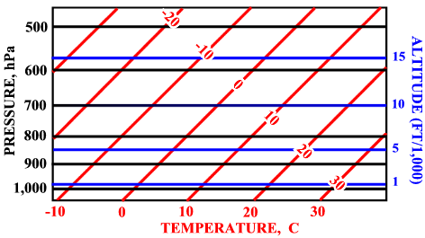
The temperature lines are at an angle (“skewed”), and the pressure scale is logarithmic because these choices make quite a few of the variables we will want to examine more-or-less linear. For clarity I had added pressure altitude lines – these are an adornment, not an integral part of the diagram.
The dry adiabatic lines tell us what happens to the temperature of a parcel of air as it rises or falls in the absence of condensation. These are the first example of what diagram I am calling “calculating lines”. They are depicted in cyan.
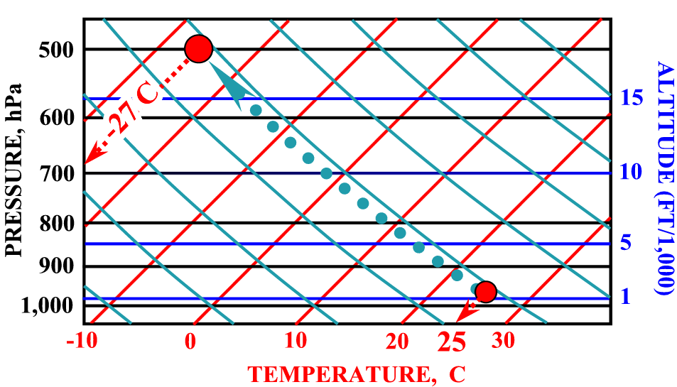

The figure depicts a spherical bubble of air at the surface, in this case at 1,200 ft msl and at a temperature of 25ºC. It tells us what happens when the bubble (parcel) of air rises to about 18,000 ft msl. In the world which has been defined by the skewT diagram, the bubble moves as though it were tied to the dry adiabat passing through the surface at 25ºC. Since there does not happen to be one of these, I have constructed one (dotted line) which is easily done. Note that because the temperature axis is indeed skewed, it is important to pick the correct temperature.
By the time to bubble is at 18,000 ft it has cooled to –27ºC and has expanded to about twice its volume. This dramatic cooling is driven entirely by the expansion of the bubble: When locally warm air ascends, its ascent is of course driven by buoyancy, but as it rises, it expands and does work pushing away the enveloping air. It is this work, achieved by tapping the internal energy of the bubble, which is responsible for the cooling.
An adiabatic process is one which takes place without exchange of heat with its surroundings so, in assuming an adiabatic process, we are assuming that the parcel of air maintains its identity and does not mix with the air through which it is moving. This is an acceptable assumption, at least in the sense that it yields useful and consistent results.
“Dry” does not mean quite what it says, since air is never dry. Specifically it means that no condensation occurs. When that happens, another adiabat is brought into play, one which I will consider later.
The lines of constant mixing ratio (the straight lines in grey in the figure below) tell us what happens to the dewpoint of a parcel of air as it rises or falls. These too are calculating lines. The dewpoint is just what the name suggests: It is the temperature at which condensation occurs when the air is cooled. Because it is condensation which is responsible for clouds, we need to understand how the dewpoint changes with altitude. Lines of constant mixing ratio tell us.

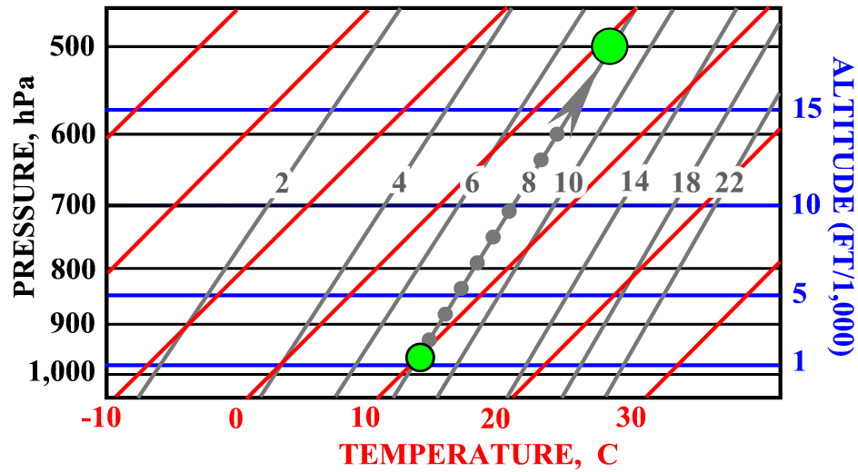

The “mixing ratio” is the concentration of water vapor in the air, expressed in grams of water per kilogram of air. Since this is a mass ratio (as opposed to a volume ratio), it does not change as a parcel of air expands or contracts. However, the dewpoint does change. The surface parcel with a DP of about 10ºC has a DP of about 2ºC at 18,000 feet.
To re-iterate: Lines of constant mixing ratio tell us how the dewpoint of a rising or falling parcel changes with altitude. The mixing ratio line passing through the surface dewpoint tells us what the dewpoint of the lifted surface parcel is at any height.
The origin of the decrease in dewpoint as a parcel ascends and cools is the associated expansion as the pressure drops. This expansion causes cooling, as we saw when considering the dry adiabats, but it also increases the average distance between water vapor molecules. Since condensation ipso facto involves an agglomeration of molecules, it is to be expected that having fewer molecules in a given volume will result in a lower dewpoint – i.e. the air will have to be colder to force condensation.
We are now in a position to understand how the skewT handles clouds. Suppose we start with a surface parcel of air having a temperature of 25ºC and a dewpoint of 10ºC:
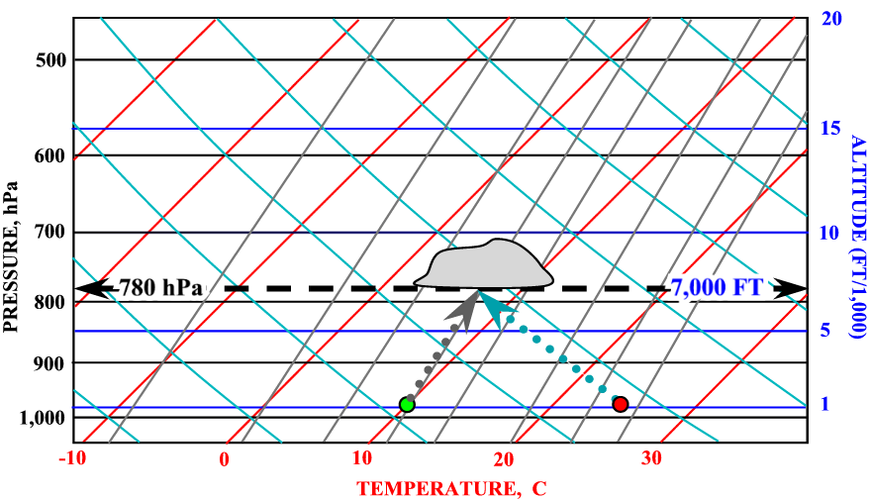

Lift the bubble to 7,000 ft. Its temperature drops to about 8ºC, and its dewpoint will drop to the same temperature: Since the DP and temperature become equal at 7,000 feet condensation must occur, and a cloud forms.

The widely used formula for cloudbase is a consequence of the differing rates of change of the temperature and dewpoint of a lifted parcel of air.
TEMPERATURE LAPSE RATE ~5.3 F° /1,000 FT.
DEWPOINT LAPSE RATE ~0.9 F°/1,000 FT

CLOUDBASE = ((T – DP) / 4.4) * 1,000 FT
It is comforting to see that our first use of the skewT diagram predicts a familiar result.
Those of you who regularly apply this rule will have noticed that it occasionally fails, since no clouds ever appear. The reason for this will soon become clear, as will the folly of relying too heavily upon the blind application of rules.
Lapse Rates

There are FOUR lapse rates with which we will be dealing: The dry adiabatic, the saturated adiabatic, the temperature, and the dewpoint. Since the one term tends to get used imprecisely, I will try to make the distinction clear.
The temperature or environmental lapse rate is what would be measured by moving a thermometer from the surface to say 20,000 ft and recording the temperature. DP lapse rate would be measured in the same way, except that a DP measurement would be made.
The Dry Adiabatic Lapse Rate is about 3C°/1,000 ft. This is how air always cools as it ascends in the absence of condensation. The Saturated Adiabatic Lapse Rate is about 2C°/1,000 ft. This is how air cools as it ascends in the presence of condensation.
In the next figure I have superimposed data lines upon the calculating lines, and it will now become apparent why the skewT diagram is so useful.

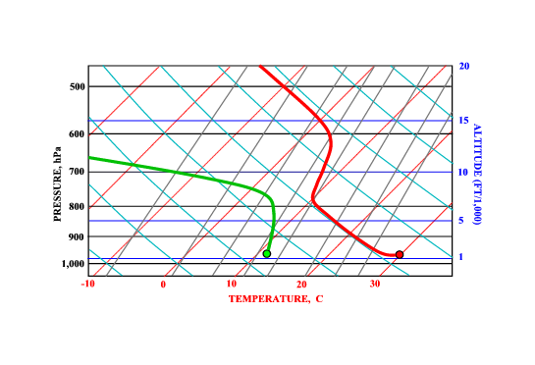
The solid red line is the temperature. It’s important to appreciate that every point on this line represents the actual, or forecast temperature of the air at a given height.
There are three regions of interest, three different lapse rates, in the red line: Close to the surface the temperature decreases rather dramatically with increasing height. Then, from about a few hundred feet above the ground to about 6,000 feet msl, the temperature decreases at the DALR. From 6,000 ft the temperature decreases much more slowly. We need to understand why each region is the way it is, and what this implies for thermal forecasting.
The lowest layer, referred to as the “super adiabatic layer” exists courtesy of the sun. Its persistence is of kinetic, not thermodynamic origin. As soon as the forcing insolation is cut off it decays because any vertical displacement will result in the air finding itself in colder air. It is “unstable” in exactly the same sense that a rock on the edge of a cliff is unstable – a small push and it’s gone. Although in the East super adiabatic layers are generally thin, they can grow to many hundreds of feet under sufficient sun, and in the absence of anything doing the equivalent of rolling that rock off the cliff, often do. This is origin of dust devils which can break loose with great energy and rise to 15,000 feet or more. Back East we accept just plain thermals.
From a few hundred feet above the surface to about 6,000 ft the temperature tracks the DALR – this is no accident: It is the very thermals we seek, and the downdrafts we avoid, which mix up the air so that its actual lapse rate inevitably becomes approximately dry adiabatic.
The next layer is generally referred to as “the inversion”. In this example, as is often the case, the temperature continues to drop with increasing height, so strictly speaking there is no inversion, however, the air above 6,000 feet is getting colder with increasing height a lot more slowly. On a blue day, it is the lowest lying inversion which caps the lift, and although this seems to place inversions in a poor light, their absence can cause problems, as I will show later on.
The solid green line is the dewpoint. The shape is typical of a thermal soaring day, particularly in the tendency for the DP and temperature to converge in the vicinity of the inversion and this too has consequences to which I shall return.

Can We Soar?
We

might as well start with a good day, so here’s one I cooked up. It’s typical of a good spring day in the East:
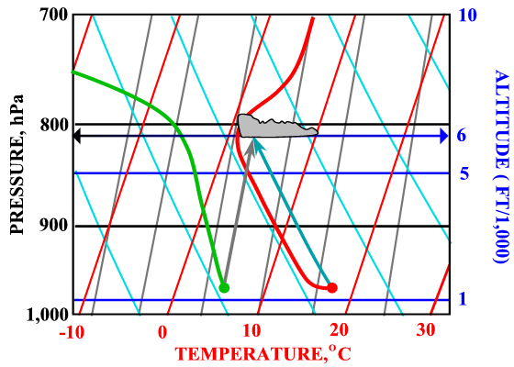
The red line is what the model thinks the temperature profile will look like. The red dot is what the model thinks the average surface temperature will be. The cyan arrow is the surface adiabat and because it is displaced from the temperature by about 2.5 C° to over 6,000 ft. it’s a pretty unstable day. The greater the displacement, the greater the instability.
The green line and green dot are what the model thinks the DP will do. In this case I have taken the surface value without change, and constructed the constant mixing ratio line passing through this value. That line intersects the surface adiabat below the inversion, telling me that on this day lift will be marked by cumulus cloud, and, because we can’t enter cloud, the base of the clouds will mark the top of the lift. As an aside, I note that at cloudbase, the air is still forecast to be 2.5 C° warmer than its surroundings, so on this day I would not expect lift to decrease with increasing height, as sometimes happens.
The DP is well behaved, so I would not anticipate spreadout, and the inversion is more than enough to cap cloud growth. Neither of these predictions can be made on the basis of what we have so far considered, and I will return to these two critical elements of the soaring forecast.
I am going to repeat much of what I said about the good day with cu, since I want to be sure everyone gets the picture, so hear is what a good day without cu looks like:

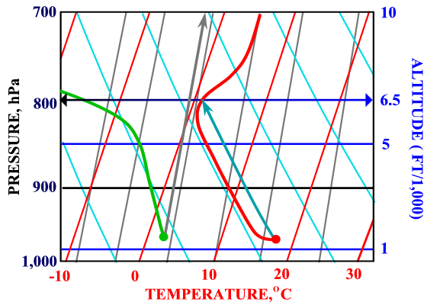
The red line is what the model thinks the temperature profile will look like. The red dot is what the model thinks the average surface temperature will be.
The cyan arrow is the surface adiabat and because it is displaced from the temperature by about 2.5C to over 6,000 ft. it’s a pretty unstable day.
The green line and green dot are what the model thinks the DP will do. In this case I have taken the surface value without change, and constructed the constant mixing ratio line passing through this value. That line intersects the surface adiabat above the inversion, telling me that on this day lift will not be marked by cumulus cloud, and as a result, lift will be capped by the inversion.
A Day in the Life of the Convective Boundary Layer
The following sequence of soundings illustrates the evolution of the convective BL. They start at 1200Z (0800h local) and are spaced at three hour intervals.
The 8AM sounding shows a
striking nocturnal inversion from the surface to about 1,000 ft. A second inversion, of quite different origin is also apparent beginning at about 7,000 ft.
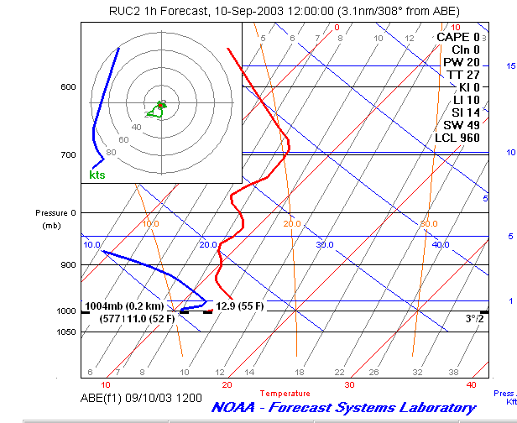
By 11AM solar heating has already fully eroded the nocturnal inversion and has forced the first 2,000 ft or so of the atmosphere to have a DALR. Soaring to about 2,000 ft would be possible.
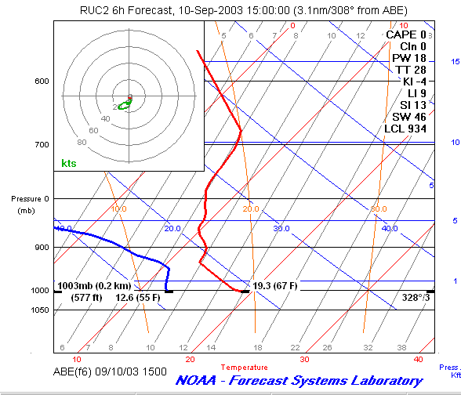fifth.
By 2PM local, solar heating at the hottest period of the day has convectively mixed the atmosphere to 5,000 ft, and that would be the height to which it would be possible to climb in the absence of cumulus cloud.

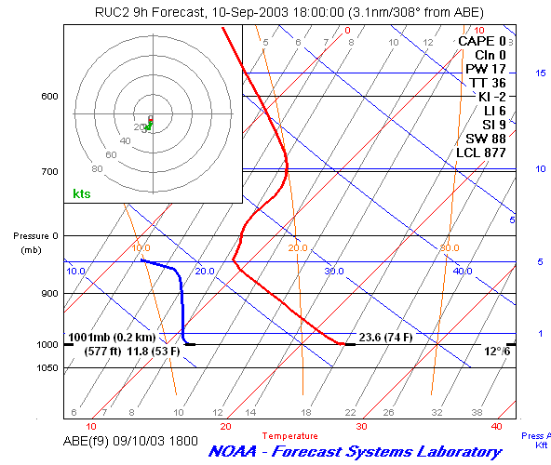
By 5PM thermal conditions are weakening somewhat, although
the nocturnal inversion has not yet started to develop.
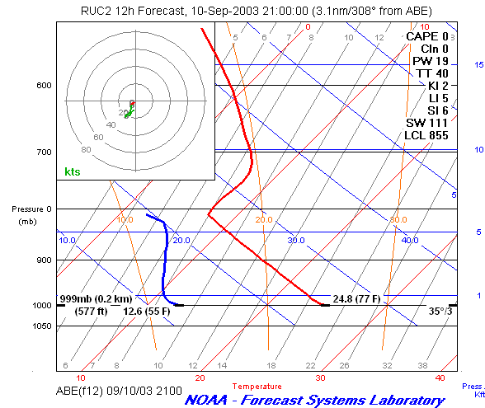develop.
We can now take a look at the evolution of the BL as the day progresses:

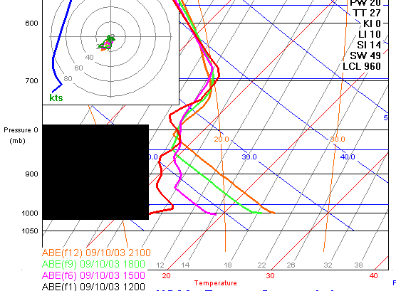

I have hidden the DP data for clarity. Notice how, as the day progresses, the convective BL thickens and warms, and how the instability grows and then wanes. These are very powerful models. I will anticipate an important point: It is NOT a good idea to arbitrarily adjust the surface temperature to allow for higher than expected temperatures: The model uses the assumed surface T value to drive convection which in turn moves the lapse rate to the right. It IS reasonable to allow for the effect of water vapor on the buoyancy of air through the use of the virtual temperature, and it is OK to investigate the effect of small increases in surface temperature on the depth of the BL and on cloudbase.

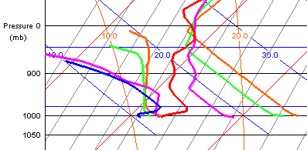

With both DP and T data visible it is clear how the insolation driven convective BL mixing also transports water vapor aloft. This quite often has major implications, as I will show.
What Goes on Above Cloudbase

In discussing the dry adiabats, I noted that when condensation occurs, a different adiabat comes into play. Condensation involves the release of heat – in the case of water vapor condensing to liquid water, large quantities of heat. Enough heat to drive convective storms and hurricanes.
In the next figure I have added (orange) saturated adiabats. Observe that these lines and the dry adiabats (cyan) have a dramatically different slope.

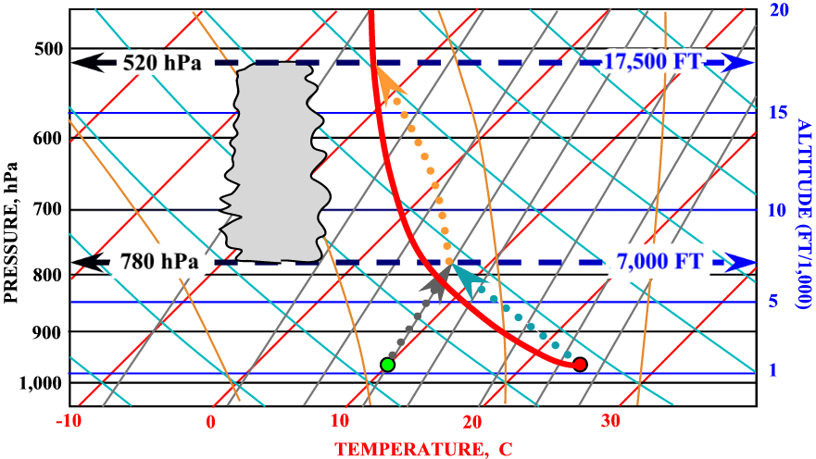
Air undergoing condensation as it ascends cools much more slowly than does non-condensing air.
The area of the figure below 780 hPa ought by now to look pretty familiar: Unstable surface air at about 24C ascends until, at 7,000 ft its temperature and dewpoint are the same, at which point condensation occurs. So far so good, after all we want cu don’t we?
The problem here is that there is no inversion in the vicinity of cloudbase. As soon as clouds form, the dotted orange adiabat takes over and the cloud will grow to about 17,500 ft. This is why, at least on days with cu, we need an inversion.
Spreadout (“Over Development”)

Many good soaring days are ruined by overdevelopment, or as I prefer to call it, spreadout. The origin of spreadout is immediately evident on inspection of this skewT:
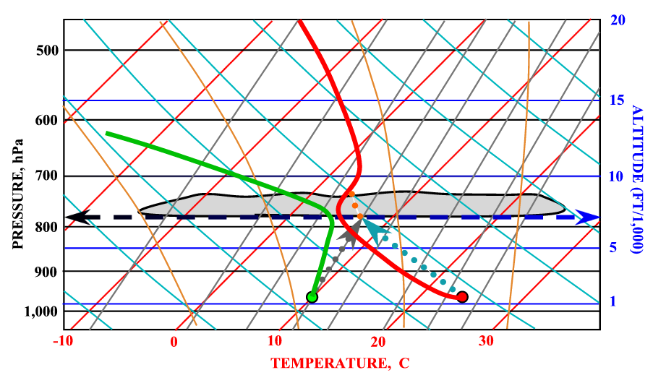
In the vicinity of cloudbase the dewpoint and temperature of the general airmass (i.e. all of the air NOT in thermals) are rather close to one another. Humidity is thus high, and dispersal of clouds through evaporation is necessarily slow.
If I see a temperature difference of less than 3C° at or in the vicinity of cloudbase, I will advise of the possibility of spreadout. The smaller the difference, the greater the chance.
It may seem perverse that the DP so frequently seems to approach the temperature at the inversion but this is no accident: The moisture is transported there by convection, and prevented from rising by the inversion.
The RUC Terrain Model
I want to say a few words about this aspect of the RUC in order to disabuse users of the notion that it somehow takes account of all terrain features.
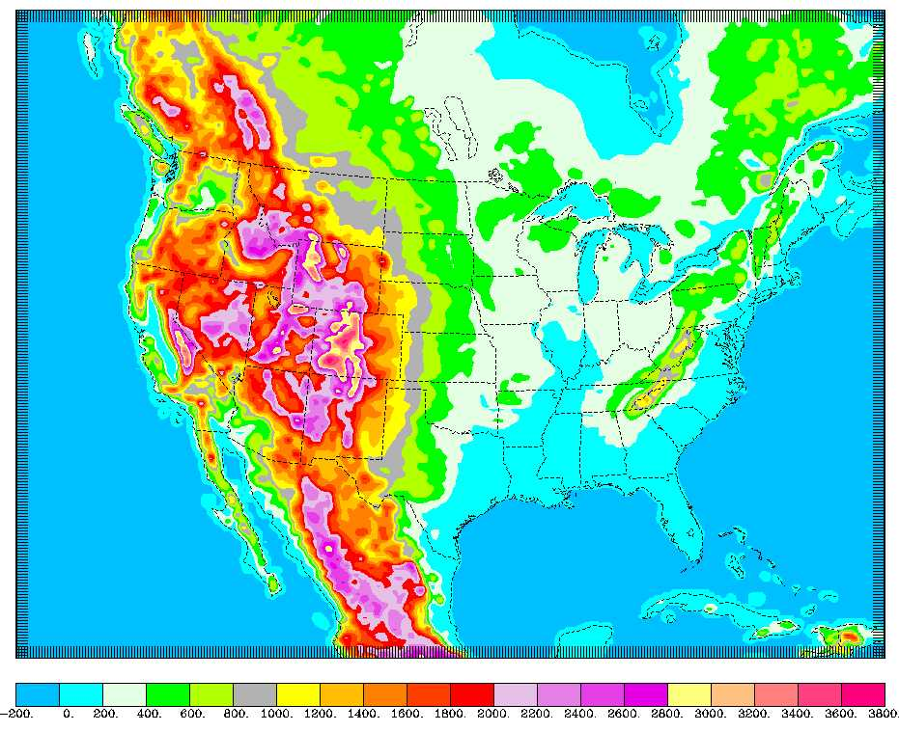
Although in many ways this terrain model is remarkable, it’s not without problems from the perspective of making soaring forecasts. Take a look at Pennsylvania: The model “knows” about the Allegheny Plateau, and the down sloping to the Susquehanna Valley. It knows nothing about any of my favorite ridges, let alone the 500 foot hills in eastern PA which generally can be counted upon to produce good lift.
The terrain modeling is invariably reflected in the BLIPMAP lift strength and BL depth output.
BLIPMAPS
The first, most obvious, and certainly best appreciated BLIPMAP feature is that it does exactly what we really want: It takes ALL of the individual soundings over the forecast area and maps the predictions. The second, less obvious attribute is that in the underlying BLIPMAP model, thermal strength is the output of a buoyancy calculation. In my methodology the lift strength is purely empirical.
BLIPMAP forecasts are based on the RUC20 model. It necessarily reflects all of the assumptions and approximations of that model.
The Effect of Moisture on Buoyancy
Air is never completely dry, and since water vapor is less dense than air, addition of water vapor decreases the density. Since buoyancy depends only on the density difference between the thermal and the surrounding air, we should in principle take account of water vapor.
The effect is significant. It is accounted for by calculating the temperature the air would be at if it were dry, and of the same density. That temperature is known as the virtual temperature. On a typical East Coast soaring day the virtual temperature is about 2 degrees higher than the 2M surface temperature. The formula for calculating virtual temperature is:
T_{v} = T + W/6
where T is the surface temperature in degrees C and W is the mixing ratio in gms of water/kg of air.
Perversely, what is displayed on every skewT diagram that I am familiar with is the uncorrected temperature, not virtual temperature so I generally make the assumption (not completely true) that a correction in the surface temperature can be made. This mostly effects the predicted height of clouds.
Wind Shear
Wind shear can be a problem, but on days when it is of sufficient magnitude to be a problem, the winds aloft are often strong enough to create other problems. A very valuable feature of BLIPMAPS is the B/S (Buoyancy/Shear) ratio. When this is less than about 6 it generally foretells problems with centering and using thermal lift. My experience suggests that the ratio is overly pessimistic when winds throughout the BL are more than about 15 kts.

Cirrus Clouds
I have found it hard to either forecast cirrus, or to estimate its effect on surface temperatures. Obviously when the DP aloft gets close to the temperature cirrus is to be expected, but where, and how much, is a mystery to me. I look at the satellite loops, and for any DP/T convergence at 30,000 ft.
Sensitivity Analysis

This is a good place to take a look at what is technically known as sensitivity analysis, but which is more easily understood in the context of a pre-emptive excuse – a key tool I might add in the forecasters bag.
When the inversion is high or weak, small changes in surface temperatures have large effects.
When the surface DP is close to the value which predicts cu, small deviations from the forecast can make the difference between cu and blue.
When the separation between dewpoint temperature and temperature is small in the vicinity of cloudbase, small errors in the forecast temperatures aloft can make the difference between few cu and to many cu or even stratocu (spreadout).
When the lapse rate at and above cloudbase is greater than about 2F°/1,000 rain showers or worse are possible if clouds are predicted to extend to the freezing level.
Low Inversion

This is a day for soaring birds and model gliders.
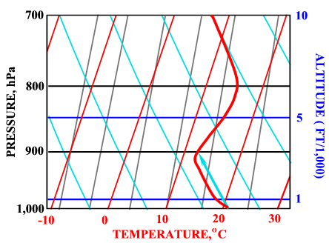
It’s also a day when forecast errors either in the surface temperature or the lapse rate, are not going to make much difference.
It’s clearly not a very unstable day, but the real problem is the low-lying and well-defined inversion. Even after allowing for hot spots, and optimistic assessments of the possible errors in forecast surface temperature, the inversion is going to cap lift at relatively low altitudes. The day is barely soarable, with weak lift to perhaps 3,000 ft msl. The lift is expected to be weak because the surface adiabat is so close to the actual temperature, and limited to about 3,000 ft msl because of the inversion. The best that might happen is that a few hot spots might produce somewhat stronger thermals.
High or Weak Inversion
Here we have a very different situation, and one which promises soarable conditions, and, I might add, headaches for the forecaster.
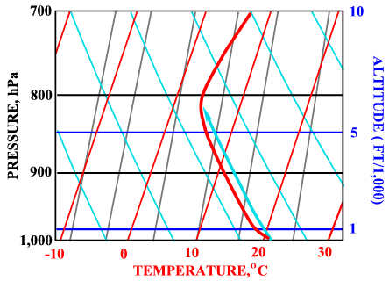
The degree of instability is about the same – about 1.5C, but the depth of instability is much greater.
So long as the thermal is less dense than its surroundings it is acted upon by a buoyancy force and so, is accelerated. The longer it is accelerated, the faster it rises. In the previous example, the buoyancy force was forecast to be zero at about 3,000 ft msl, here at about 6,000 ft msl, so its reasonable to expect stronger lift, at least at higher altitudes.
In the absence (or near absence) of an inversion quite small changes in surface temperature have very large effects, and on days such as this there is a good deal of uncertainty about the forecast.

Cautionary Notes and Conclusion
As I have emphasized, not even the RUC20 model comes close to taking into account even rather large terrain features systematically sought out by glider pilots, let alone parking lots, patches of bare rock on slopes inclined to the sun, and a number of features which can cause low-level convergence (tree lines, land/water transitions, hills and ridges etc).
The model sees the world as it is projected onto a 20KM grid – at a guess, pilots with average eyesight and processing power interpret the ground below them and the air through which they fly on a 0.1KM grid.

After doing your own forecast, you will be in a much better position to appreciate the work of others, and you will have extracted even more enjoyment from this extraordinary hobby of ours.

QV, Tuesday, May 31, 2005

richard@nkhome.com

